**CDAC Mumbai PG-DAC AUGUST 24**

**Assignment No- 2**

1)Write a program that checks if a given year is a leap year or not using both if-else and switch-case.

Code :

import java.util.Scanner;

public class Leap {

public static void main(String[] args) {

Scanner sc = new Scanner(System.in);

int year;

System.out.print("Enter a year: ");

year = sc.nextInt();

if (year % 400 == 0) {

System.out.println(year + " is a Leap Year");

} else if (year % 100 == 0) {

System.out.println(year + " is not a Leap Year");

} else if (year % 4 == 0) {

System.out.println(year + " is a Leap Year");

} else {

System.out.println(year + " is not a Leap Year");

}

}

}

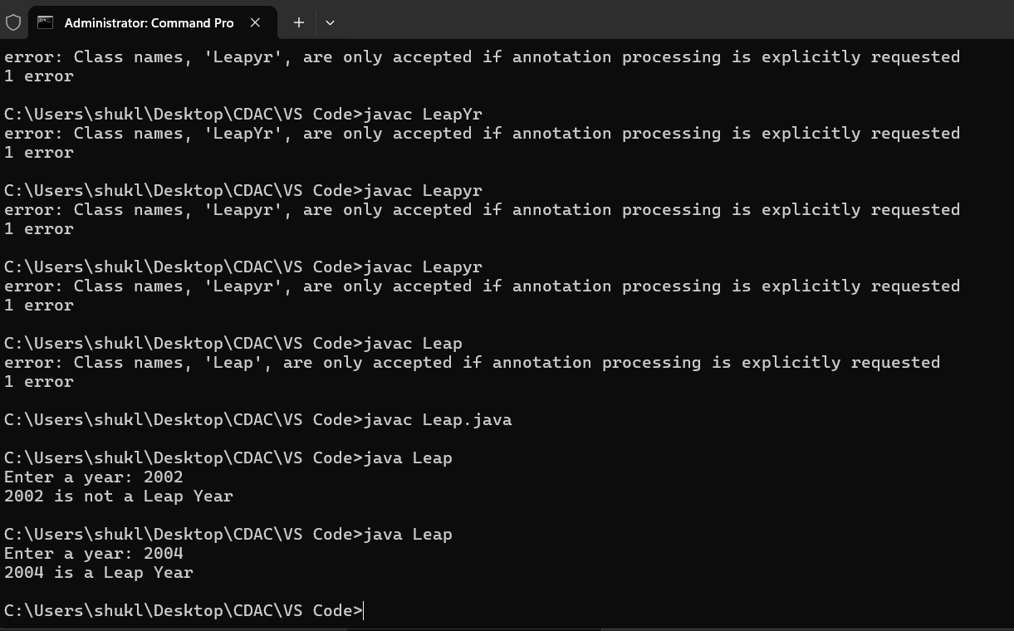

2)Implement a program that calculates the Body Mass Index (BMI) based on height and weight input using if-else to classify the BMI int categories (underweight, normal weight, overweight,etc).

Code:

import java.util.Scanner;

public class BMI {

public static void main(String[] args) {

Scanner sc = new Scanner(System.in);

System.out.print("Enter your height in meters: ");

double ht = sc.nextDouble();

System.out.print("Enter your weight in kilograms: ");

double wt = sc.nextDouble();

double bmi = wt / (ht * ht);

System.out.printf("Your BMI is: %.2f%n", bmi);

if (bmi < 18.5) {

System.out.println("You are underweight.");

} else if (bmi >= 18.5 && bmi < 24.9) {

System.out.println("You have a normal weight.");

} else if (bmi >= 25 && bmi < 29.9) {

System.out.println("You are overweight.");

} else {

System.out.println("You are obese.");

}

sc.close();

}

}

3)Write a program that checks if a person is eligible to vote based on their age.

Code:

import java.util.*;

public class Monu {

public static void main(String[] args) {

Scanner sc = new Scanner(System.in);

System.out.println("Enter Your Age: ");

int age = sc.nextInt();

if (age <= 17) {

System.out.println("You are not Eligible to Vote.");

} else { // No need to check age >= 18, because it's the only other option

System.out.println("You are Eligible to Vote.");

}

sc.close();

}

}

4)Write a program that takes a month (1-12) and prints the corresponding season (Winter, Spring, Summer, Autumn) using a switch case

Code:

import java.util.Scanner;

public class First {

public static void main(String[] args) {

Scanner sc = new Scanner(System.in);

// Prompt the user to enter the month

System.out.println("Enter the month (1-12): ");

int month = sc.nextInt();

// Determine the season based on the month

String season;

switch (month) {

case 1: // January

case 2: // February

case 12: // December

season = "Winter";

break;

case 3: // March

case 4: // April

case 5: // May

season = "Spring";

break;

case 6: // June

case 7: // July

case 8: // August

season = "Summer";

break;

case 9: // September

case 10: // October

case 11: // November

season = "Autumn";

break;

default:

season = "Invalid month. Please enter a number between 1 and 12.";

break;

}

// Print the corresponding season

System.out.println("The season is: " + season);

// Close the scanner

sc.close();

}

}

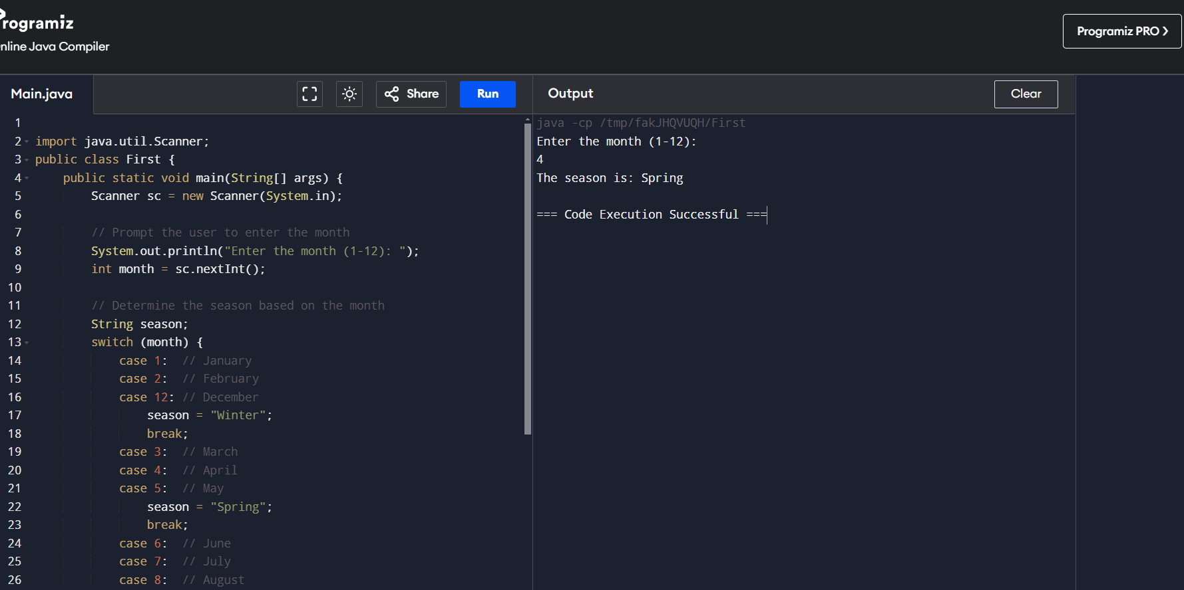

5)Write a program that allows the user to select a shape (Circle, Square, Rectangle, Triangle) and then calculates the area based on user-provided dimensions using a switch case.

